**What is a Data Warehouse?**

Imagine a huge digital library that stores all the information a business has gathered over the years—sales records, customer feedback, inventory levels, and even how users behave on their website. Now imagine this library not only stores the information but organizes it in a way that makes it super easy to find patterns, compare data, and make decisions. That’s essentially what a Data Warehouse is.

A **Data Warehouse** is a specialized system used to store and analyse large amounts of data collected from various sources within an organization. Unlike regular databases that are used for everyday tasks like recording sales or managing customer accounts, a data warehouse is designed specifically for analysis, reporting, and decision-making.

**Why Do We Need a Data Warehouse?**

Most businesses have multiple sources of data—like sales systems, customer support tools, marketing platforms, and so on. Each of these might store data in different formats. For example, a sales system might store prices and purchase dates, while a customer service system might store complaint details.

If someone in management wants to know, "Do customers who complain a lot also stop buying products?"—it would be hard to get that answer directly from these separate systems. That’s where a data warehouse comes in. It **combines** all that data into one central place, **cleans it up**, and **organizes it** so that patterns and insights are easy to find.

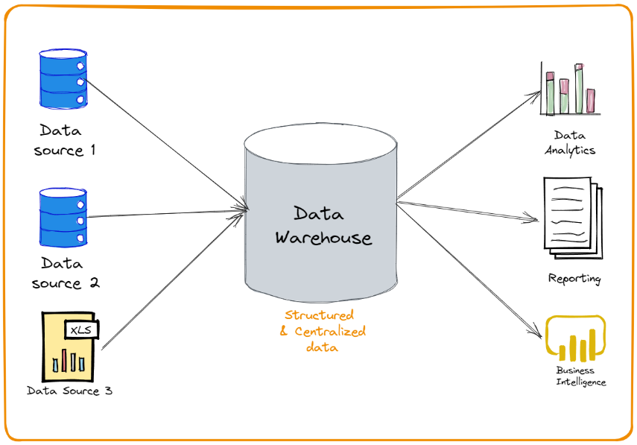

**Key Characteristics of a Data Warehouse**

Let’s break down what makes a data warehouse different from a regular database.

**1. Subject-Oriented**

A data warehouse focuses on specific subjects like sales, customers, or products, rather than day-to-day operations. It organizes data around these high-level topics to make analysis easier.

**2. Integrated**

It collects data from different sources—like Excel files, online apps, internal databases—and converts them into a **common format**. This ensures that the data is consistent and reliable.

**3. Time-Variant**

A data warehouse keeps historical data, which allows businesses to track changes and trends over time. While regular databases might only store the latest data, a data warehouse preserves the past.

**4. Non-Volatile**

Once the data is stored in a data warehouse, it doesn’t usually get changed or deleted. This makes it perfect for generating accurate and repeatable reports.

**How Does a Data Warehouse Work?**

The process of building and using a data warehouse usually involves three main steps:

**1. ETL – Extract, Transform, Load**

* **Extract**: Data is pulled out from different sources.
* **Transform**: The data is cleaned, corrected, and converted into a consistent format.
* **Load**: The transformed data is loaded into the warehouse.

Think of it like cooking: you gather ingredients (extract), wash and cut them (transform), and then put them into the final dish (load).

**2. Storage**

Once the data is loaded into the warehouse, it is stored in a way that supports fast queries and large-scale analysis. This is often done using optimized storage methods like star schemas or snowflake schemas.

**3. Analysis and Reporting**

Now comes the real value. Analysts, managers, and executives can use tools like dashboards, reports, and even AI systems to generate insights from the stored data. It allows them to make **data-driven decisions** instead of just guessing or relying on intuition

**Components of a Data Warehouse**

A complete data warehouse system usually includes the following parts:

**1. Data Sources**

These are the places where the raw data comes from—ERP systems, CRM software, spreadsheets, APIs, social media, etc.

**2. ETL Tools**

Tools or scripts that perform the Extract, Transform, and Load processes. Examples: Apache Nifi, Talend, Informatica.

**3. Data Storage**

The actual warehouse where the cleaned and transformed data is stored. It could be on-premise (physical servers) or in the cloud (like AWS Redshift, Google BigQuery).

**4. Metadata**

This is like the "table of contents" for your data. It tells you what data is stored, where it came from, and how it has been transformed.

**5. Query Tools**

These help users explore the data using SQL or visual interfaces. Tools like Power BI, Tableau, and Looker allow even non-technical users to understand the data.

**Types of Data Warehouses**

There are mainly three types of data warehouses:

**1. Enterprise Data Warehouse (EDW)**

This is the central warehouse for the entire organization. It provides a unified view of all data and supports decision-making across departments.

**2. Operational Data Store (ODS)**

This is used when reporting needs to be done in near real-time. It's not as historical as an EDW and is more frequently updated.

**3. Data Mart**

These are smaller, subject-specific warehouses—like one for sales, one for marketing, etc. They are quicker to build and easier to manage than a full EDW.

**Benefits of a Data Warehouse**

1. **Better Decision Making**: With all the data in one place, it's easier to analyze trends and make informed decisions.
2. **Improved Business Intelligence**: Dashboards and reports become more powerful and reliable.
3. **Historical Analysis**: Businesses can look at data over time to see how they’ve grown or where they’ve struggled.
4. **Data Consistency**: Everyone works with the same version of the truth.
5. **Faster Queries**: Optimized for reading large amounts of data quickly.

**Challenges and Limitations**

Of course, building a data warehouse isn't all sunshine and rainbows.

* **Cost**: It can be expensive to set up and maintain.
* **Complexity**: Integrating different data sources and transforming them properly requires technical skill.
* **Data Quality**: Bad input = bad output. If the original data sources are messy, the warehouse might not help much.
* **Time**: It can take months to build a fully functional data warehouse.

**Modern Trends in Data Warehousing**

With the rise of cloud computing and AI, data warehousing has evolved too. Some current trends include:

* **Cloud Data Warehousing**: Tools like Snowflake, BigQuery, and Azure Synapse offer flexible, scalable, and cost-effective solutions.
* **Real-time Warehousing**: Some companies are moving toward real-time data updates instead of waiting for nightly batches.
* **Data Lakes**: These are used to store unstructured data like videos, images, and raw logs. Some modern warehouses combine both traditional and unstructured data storage.

**Conclusion**

In simple words, a **Data Warehouse** is the brain of an organization’s information system. It collects all data from different sources, organizes it neatly, and allows users to make sense of it for better decision-making. While building and maintaining one can be a complex task, the value it offers—especially in today’s data-driven world—is massive.

Whether it’s predicting sales trends, understanding customer behavior, or optimizing operations, a well-designed data warehouse serves as the foundation for powerful business intelligence and analytics. It's not just about storing data—it's about **unlocking knowledge** from it.